2017 ESS National Open Championship Merchandise
MERCHANDISE WILL BE SOLD BY PRE-ORDER ONLY. ORDER DEADLINE IS WEDNESDAY, OCTOBER 25TH.
All merchandise will be embroidered with the 2017 NOC logo shown on the cap below. Merchandise will be distributed at the NOC.
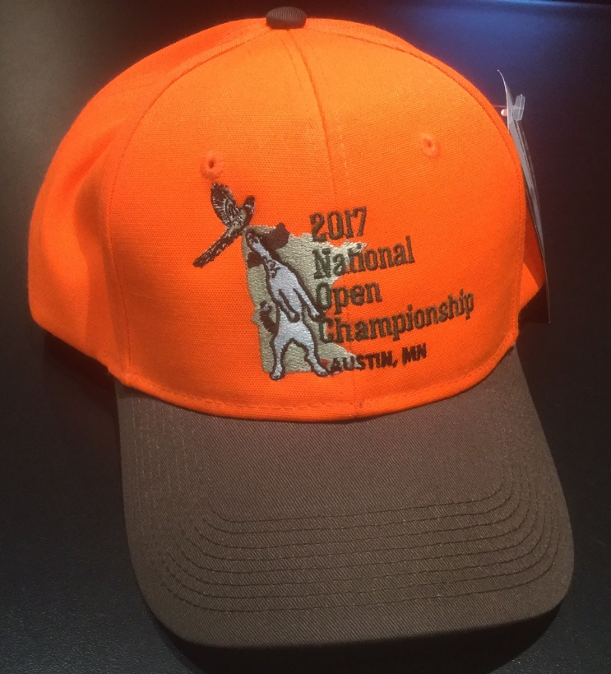
CAP
Cap America medium profile six-panel structured cap
Blaze orange with brown visor & button
Fabric strap with two-piece Velcro closure
2017 NOC embroidered logo
One size
$20.00

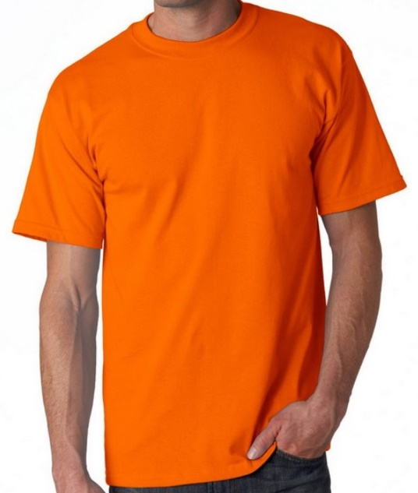
T-SHIRT
Safety orange with 2017 NOC embroidered logo
Gildan 6 ounce 50/50 cotton/polyester blend
Double-needle stitched neckline, bottom hem & sleeves
Quarter-turned, Taped neck & shoulders
Sizes S – 6XL
$25.00
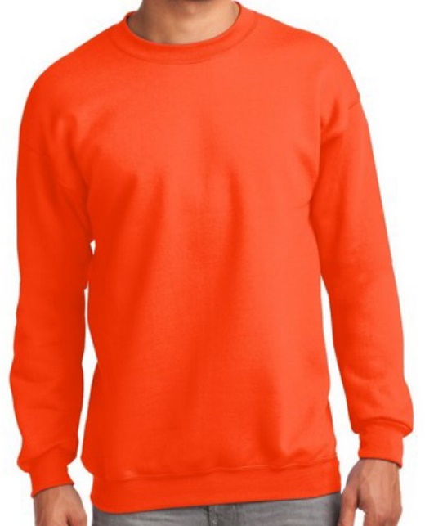
SWEATSHIRT
Safety orange with 2017 NOC embroidered logo
Port and Company 9 ounce 50/50 cotton/polyester fleece
Crew neck
Air jet yarn for a soft, pill resistant finish
Sizes S – 4XL
$35.00

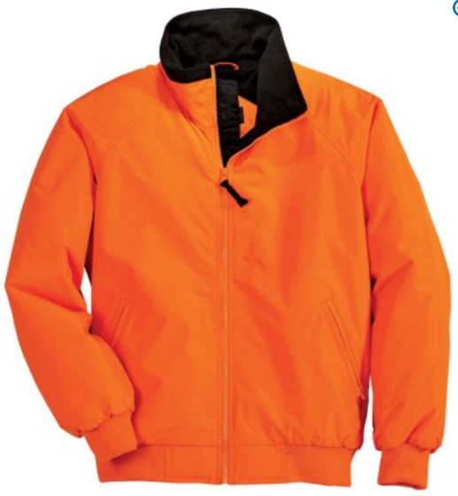
JACKET
Port Authority Enhanced Visibility Challenger Jacket
Safety orange with 2017 NOC embroidered logo
Durable 100% polyester water-resistant shell
Poly-filled with heavyweight fleece lining
Rib knit cuffs and waistband
Slash zippered pockets, interior zippered pocket
Sizes S – 6XL
$85.00

2017 ESS NATIONAL OPEN CHAMPIONSHIP MERCHANDISE ORDER FORM
Name: ___________________________
Item: | Price | No. Ordered | Sizes | Amount:
CAP | $20 |  | -- One size -- | $
T-SHIRT | $25 |  |  | $
SWEATSHIRT | $35 |  |  | $
JACKET | $85 |  |  | $
 |  |  | Total: | $
Make checks payable to: NESSFTA
Send orders with payment to:
Dean Koehler
15822 Jocko Ct
Shakopee, MN 55379-7512
Contact info: koehlerd@umn.edu, 507-236-1268

Orders must be received by Wednesday, October 25th!!!

