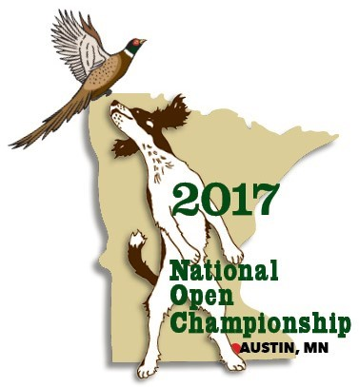
2017 Nation Open Championship Silent Auction Donation Form
During the 2017 NOC we will be holding a Silent Auction. The money raised will be used to help fund the NOC. Generous donations from clubs and individuals across the country help make this event possible.
Please consider donating an item to be included in the silent auction. Auction items can include hand-crafted items, dog training supplies, gift baskets, etc. Please complete the form below with an item that you or your club will be donating and return this form to us at your earliest convenience.
NOC Silent Auction

Name
or
Club Name
Address
Email
Phone
Item(s) donated:
Estimated Value $
We will be sending the items – by Nov 8
We (or someone from our club) will bring the item to the NOC headquarters, Austin Holiday Inn Conference Center, by Nov 14th.
Please return this form to 2017 NOC Silent Auction, Attn: Katie Gorecki, 17556 300th Ave, Starbuck, MN 56381, krgorecki@gmail.com, 320-287-0654
Dean Koehler, 2017 NOC President, 507-236-1268, koehlerd@umn.edu

