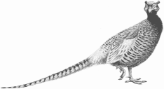

English Springer Spaniel Field Trial Association
and
Volunteer English Springer Spaniel Club
Hall of Fame Banquet
February 8, 2018
National Bird Dog Museum
Grand Junction, Tennessee
6:00pm-Cocktails 7:00-Dinner

Please fill out the form below and send in with your check payment.

Name:______________________________________________________________________

Phone:_____________________________________________________________________

Cost: $45 per person (includes either a 12oz Ribeye or Chicken, 2 vegetables, salad, roll, drink and dessert)

Number of Meals:______________________

Amount Enclosed:_____________________

Preference (please circle): Steak Chicken

Make check payable to: Volunteer English Springer Spaniel Club

Send payment to: Ginger Crenshaw
8787 Hwy 7
Michigan City, MS 38647

