Fellow Field Trial Competitors and Enthusiasts,

The Stockton English Springer Spaniel Training Club (SESSTC) is pleased to invite you to our spring trial to be held on February 10th and 11th, 2018 at the Grizzly Island Wildlife Area
2548 Grizzly Island Road, Suisun City, CA 94585 (707) 425-3828

Open and Amateur Judges: Bob Bullard from Oregon and Gregory Kuhlman from New Mexico.
Puppy Judges: To be announced.

Entry Deadline: Tuesday, January 30, 2018 at 8:00 PM

Saturday awards will be presented on the grounds immediately after the trial.
Sunday awards will be presented on the grounds immediately after the trial.
Lunch will be available on the grounds for a fee.

Headquarters are at: Extended Stay, 1019 Oliver Road, Fairfield, CA - (707) 438-0932

Other lodging: Motel 6 Fairfield North #1035
1473 Holiday Lane, I-80 at Travis Boulevard , Fairfield, CA 94534 Phone (707) 425-4565

No training is allowed on the grounds prior to the event. Dogs must be aired in specific areas. A map will be posted at the check station parking lot. Blaze Orange is required to be worn above the waist by all participants and observers. Protective eye-wear is recommended for everyone on the grounds.

Note: Excused scratches for bitches in season. Other scratches will be excused at the discretion of the field trial committee.

Emergency Contacts for fire and police: call 911
Emergency Vet: Solano/Napa Pet Emergency Clinic, 4437 Central Pl. Suite B3
Fairfield, CA. 94534 (707) 410-5530

Please consider placing an ad in our catalog: Full-page ads $25.00, half-page ads $15. Patrons, choose an amount. Camera-ready ads in pdf format preferred, but we can typeset one for you. Email your ad to the Field Trial Secretary by Tuesday, January 30, 2018.

We hope to see you there.

Claire Berkley: Field Trial Secretary Mike Blair: Co-Chair
Phone: (530) 370-4004 Phone: (916) 837-3589
claire.lund.berkley@gmail.com mblair@surewest.net

Gordon Johnson: Co-Chair
Phone: (530) 885-0201
gandljohnson@juno.com
Event #2018369103
Field Trial Premium List
Stockton English Springer Spaniel Training Club
AKC Licensed

February 10th and 11th 2018

Grizzly Island Wildlife Area, Suisun City, CA

Open to any English Springer Spaniel six months of age or older
This field trial is held under the rules and procedures of the American Kennel Club

Mail advance entries with checks to:
Stockton English Springer Spaniel Training Club
In care Of:
Claire Berkley, 215 B Street, Biggs, CA 95917

Entries will close with the Field Trial Secretary
8:00 P.M (PST) Tuesday, January 30, 2018

Drawing will take place at:
215 B Street, Biggs, CA 95917
8:00 P.M (PST) Wednesday, January 31, 2018

Judges for Open and Amateur all age:
Gregory Kuhlman of New Mexico and Robert Bullard of Oregon

Judges for Puppy Stake:
To be announced

Gun Captain: Roger Thorne

Field Trial Headquarters:
Extended Stay in Fairfield (707) 438-0932

Stakes Schedule and Entry Fees

Amateur All-Age Stake $125
8:00 a.m., Saturday, February 10, 2018

Puppy Stake $40
Following the second series, Saturday, February 10, 2018

Open All-Age Stake $125
8:00 a.m., Sunday, February 11, 2018

Course and Birds
Pheasants in the Open and Amateur All-Age Stakes
Pigeons in the Puppy Stake

Prizes
Standard AKC Rosettes to All Placed Dogs
Trophies to First Place Dogs in All Stakes

Club Officers
Mike Blair: President
Gordon Johnson: Vice-President
Suzanne Woll: Secretary
Renee Shannon: Treasurer
Roy Harris &Mark Pitts: Board Members

Field Trial Committee
Chairman: Mike Blair
mblair@surewest.net (916)837-3589
2567 Woodgate Way, Roseville, CA 95747

Co-Chairman: Gordon Johnson
gandljohnson@juno.com (530) 885-0201
152 S McDaniel Drive, Auburn, CA 95603

Committee Members
Gordon Johnson, Skip Shannon, Renee Shannon, Mark Pitts, Claire Berkley, Mike Blair
2018 Field Trial
Reservation Form for Entries and Catalog Advertising

Stockton English Springer Spaniel Training Club

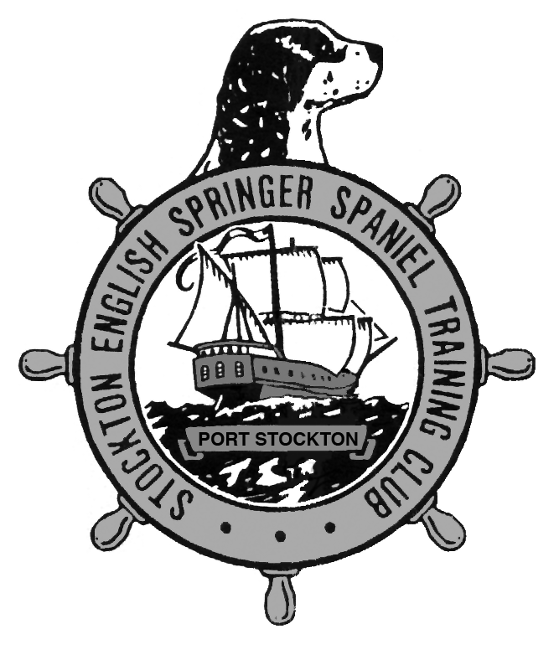

Name __________________________________________________________

Email address ____________________________________________________

Open ___ Dogs @ $125 _$_______

Amateur ___ Dogs @ $125 _$_______

Puppy ___ Dogs @ $40 _$_______

Ad Full Page $25 _$_______
Half Page $15 _$_______
Send press-ready ad by email or ad copy with your entries

Patron Ad - you choose amount _$_______

Total Enclosed _$_______

No entries will be accepted after the deadline: Tuesday January 30, 2018

Please return reservation form and entries with check payable to SESSTC
To: Claire Berkley, 215 B Street, Biggs, CA 95917

OFFICIAL AMERICAN KENNEL CLUB FIELD TRIAL ENTRY FORM
Note: This Entry Form Must Be Completed in Full
STOCKTON ENGLISH SPRINGER SPANIEL TRAINING CLUB
2548 GRIZZLY ISLAND RD, SUISUN CITY, CA 94585
FEBRUARY 10th AND 11th , 2018
I SUBMIT $ for entry fees. EVENT # 2018369103
Enter in Stake/Test: x Open All-Age Amateur All-Age Puppy
NAME OF CALL
DOG (Print) NAME
A.K.C. Reg Or A.K.C. Litter Number
Number (If Dog Not Reg.)
Or Foreign Reg. No. And Country of Registry
Breed English Springer Spaniel MALE FEMALE Date of Birth:
Sire
Dam
Breeder
Name of Actual Owner (Print)
Owner's Address
State Zip Code
Name of Owners Agent/Handler (Print)
Phone Email
AKC Rules, Regulations, Policies and Guidelines are available on the American Kennel Club website at www.akc.org
AGREEMENT
I certify that I am the actual owner of the dog, or that I am the duly authorized agent of the actual owner whose name I have entered above. In consideration of the acceptance of this entry, I (we) agree to abide by the rules and regulations of the American Kennel Club in effect at the time of this event, and any additional rules and regulations appearing in the premium list of this event and entry form and any decision made in accord with them. I (we) agree that the club holding this event has the right to refuse this entry for cause which the club shall deem sufficient. In consideration of the acceptance of this entry and of the holding of this event and of the opportunity to have the dog judged and to win prizes, ribbons, or trophies, I (we) agree to hold the AKC, the event-giving club, their members, directors, governors, officers, agents, superintendents or event secretary and the owner and/or lessor of the premises and any provider of services that are necessary to hold this event and any employees or volunteers of the aforementioned parties, and any AKC approved judge, judging at this event, harmless from any claim for loss or injury which may be alleged to have been caused directly or indirectly to any person or thing by the act of this dog while in or about the event premises or grounds or near any entrance thereto, and I (we) personally assume all responsibility and liability for any such claim; and I (we) further agree to hold the aforementioned parties harmless from any claim for loss, injury or damage to this dog. Additionally, I (we) hereby assume the sole responsibility for and agree to indemnify, defend and save the aforementioned parties harmless from any and all loss and expense (including legal fees) by reason of the liability imposed by law upon any of the aforementioned parties for damage because of bodily injuries, including death at any time resulting therefrom, sustained by any person or persons, including myself (ourselves), or on account of damage to property, arising out of or in consequence of my (our) participation in this event, however such, injuries, death or property damage may be caused, and whether or not the same may have been caused or may be alleged to have been caused by the negligence of the aforementioned parties or any of their employees, agents, or any other persons. I (we) agree that any cause of action, controversy or claim arising out of or related to the entry, exhibition or attendance at the event between the AKC and myself (ourselves) or as to the construction, interpretation and effect of this Agreement shall be settled by arbitration pursuant to the applicable rules of the American Arbitration Association. However, prior to arbitration all applicable AKC Bylaws, rules, regulations and procedures must first be followed as set forth in the AKC Charter and Bylaws, rules, regulations, published policies and guidelines.
SIGNATURE of Owner or His Agent
Duly Authorized to Make this Entry

OFFICIAL AMERICAN KENNEL CLUB FIELD TRIAL ENTRY FORM
Note: This Entry Form Must Be Completed in Full
STOCKTON ENGLISH SPRINGER SPANIEL TRAINING CLUB
2548 GRIZZLY ISLAND RD, SUISUN CITY, CA 94585
FEBRUARY 10th AND 11th, 2018
I SUBMIT $ for entry fees. EVENT # 2017369103
Enter in Stake/Test: X Open All-Age Amateur All-Age Puppy
NAME OF CALL
DOG (Print) NAME
A.K.C. Reg Or A.K.C. Litter Number
Number (If Dog Not Reg.)
Or Foreign Reg. No. And Country of Registry
Breed English Springer Spaniel MALE FEMALE Date of Birth:
Sire
Dam
Breeder
Name of Actual Owner (Print)
Owner's Address
City State Zip Code
Name of Owners Agent/Handler (Print)
Phone Email
AKC Rules, Regulations, Policies and Guidelines are available on the American Kennel Club website at www.akc.org
AGREEMENT
I certify that I am the actual owner of the dog, or that I am the duly authorized agent of the actual owner whose name I have entered above. In consideration of the acceptance of this entry, I (we) agree to abide by the rules and regulations of the American Kennel Club in effect at the time of this event, and any additional rules and regulations appearing in the premium list of this event and entry form and any decision made in accord with them. I (we) agree that the club holding this event has the right to refuse this entry for cause which the club shall deem sufficient. In consideration of the acceptance of this entry and of the holding of this event and of the opportunity to have the dog judged and to win prizes, ribbons, or trophies, I (we) agree to hold the AKC, the event-giving club, their members, directors, governors, officers, agents, superintendents or event secretary and the owner and/or lessor of the premises and any provider of services that are necessary to hold this event and any employees or volunteers of the aforementioned parties, and any AKC approved judge, judging at this event, harmless from any claim for loss or injury which may be alleged to have been caused directly or indirectly to any person or thing by the act of this dog while in or about the event premises or grounds or near any entrance thereto, and I (we) personally assume all responsibility and liability for any such claim; and I (we) further agree to hold the aforementioned parties harmless from any claim for loss, injury or damage to this dog. Additionally, I (we) hereby assume the sole responsibility for and agree to indemnify, defend and save the aforementioned parties harmless from any and all loss and expense (including legal fees) by reason of the liability imposed by law upon any of the aforementioned parties for damage because of bodily injuries, including death at any time resulting therefrom, sustained by any person or persons, including myself (ourselves), or on account of damage to property, arising out of or in consequence of my (our) participation in this event, however such, injuries, death or property damage may be caused, and whether or not the same may have been caused or may be alleged to have been caused by the negligence of the aforementioned parties or any of their employees, agents, or any other persons. I (we) agree that any cause of action, controversy or claim arising out of or related to the entry, exhibition or attendance at the event between the AKC and myself (ourselves) or as to the construction, interpretation and effect of this Agreement shall be settled by arbitration pursuant to the applicable rules of the American Arbitration Association. However, prior to arbitration all applicable AKC Bylaws, rules, regulations and procedures must first be followed as set forth in the AKC Charter and Bylaws, rules, regulations, published policies and guidelines.
SIGNATURE of Owner or His Agent
Duly Authorized to Make this Entry

