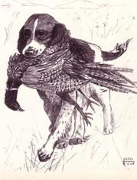
New Jersey Spaniel Field Trial Club
Presents
THE NEW JERSEY FUTURITY CLASSIC
This event is open to Springer Spaniels born in 2017. Dogs will be judged on innate, natural ability and need not be steady to wing and shot.
Date: Saturday, April 14, 2018
Place: Jim Boone’s Hunt Club (Formerly Hillendale Hunt Club), Tyrone, PA
Time: 7:30
Game: Chukars or pigeons
Entry Fee: $20.00 nomination fee + $65.00 entry fee
Judges: Frank Mackinson and Garry Soper
Awards: A cash award and rosette ribbons to 1st place through 4th place. Keeper plate to 1st place puppy.
Chairman: Ralph Botti

New Jersey Futurity Classic Nomination Form

Name of Puppy: ________________________________ Date of Birth:_________ Sex M F
Sire: _________________________________________ Dam: _____________________________________
Breeder: ______________________________________ Handler: __________________________________
Owner: _______________________________________ AKC Reg/Litter No. __________________________
Owner: _______________________________________ Address: __________________________________
Email: ________________________________________ __________________________________
Phone: ________________________________________

Entries close April 9, 2018. Return Nomination and fee to: Connie Soper
772 Lexington Dr.
Brick, NJ 08724
soperc@ymail.com

