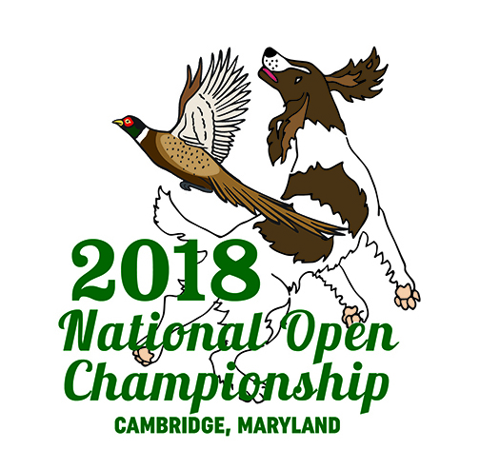
National English Springer Spaniel
Open Championship Cart Sponsorship
As a cart sponsor you will be cheering our competitors on with a banner with your choice of print or high resolution photo on the front, displayed on one of our carts. Each cart sponsorship is $250.
If you would like to sponsor a cart, please contact me by November 19, 2018, to secure your sponsorship..
RDCGSchuster@aol.com
920-427-8540
Dawn Schuster
N2090 Hwy 55
Kaukauna, WI 54130
Thank you for your support!
Dawn Schuster
NOC Fundraising Chair 2018

