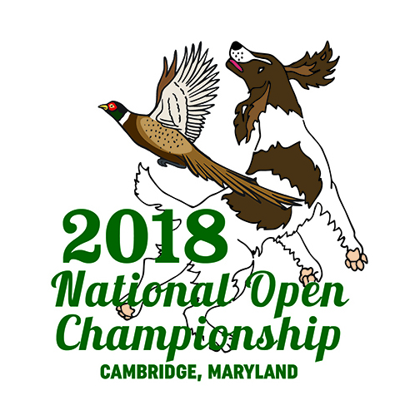
National English Springer Spaniel
Open Championships 2018
Flag Sponsorship
Flag sponsorships are $25 for each flag. Flags will be placed on the series courses. Each flag will be printed with the text you have selected. A flag sponsorship can be in memory of a person or dog, in the name of a kennel or business, or in your own name. What a great memento!
At the end of the NOC, you will be free to take your flag pennant.
Please fill in the information below and return it with a check, cash or money order, no later than November 19, 2018, made out to…
ESSFT NOC 2018
c/o
Dawn Schuster
N2090 Hwy 55
Kaukauna, WI 54130
Name, address, phone number and email of person purchasing the sponsorship. ____________________________________________________________________________________________________________________________________________________________
exact print you would like on your flag.
____________________________________________________________________________________________________________________________________________________________
Thank you for your donation!
Dawn Schuster RDCGSchuster@aol.com 920-427-8540
Fundraising Committee NOC 2018

