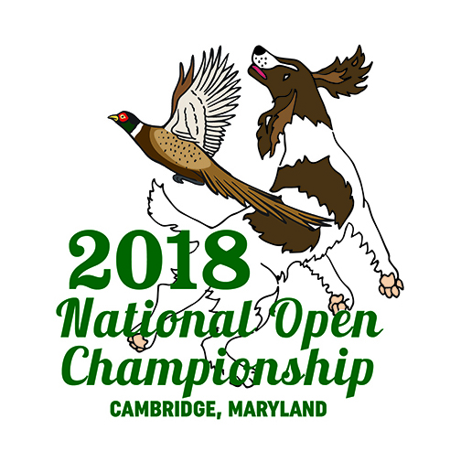
National English Springer Spaniel
Open Championship Series Sponsorship
As a series sponsorship you will be cheering our competitors on with a banner with your choice of print on the front, displayed at the start of the series you wish to sponsor. Each series sponsorship is $500
There are 6 series to select from. Series 1, 2, 3, 4, 5 and the water series.
If you would like to sponsor a series, please contact me by November 19, 2018 …
RDCGSchuster@aol.com
920-427-8540
Dawn Schuster
N2090 Hwy 55
Kaukauna, WI 54130
Thank you for your support!
Dawn Schuster
NOC Fundraising Chair 2018

