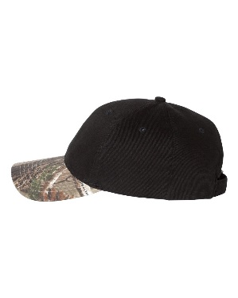
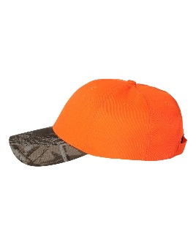
Brushed cotton/polyester blend
- Blaze is 100% polyester
- Structured, six-panel, mid-profile
- Pre-curved camouflage visor
- Sewn eyelets
- Self-fabric Flex-Strap closure

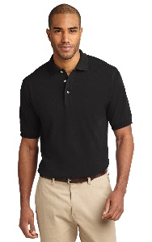
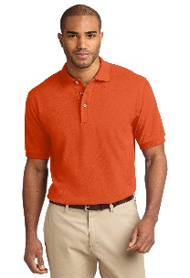
- 7-ounce, 100% ring spun combed cotton heavyweight pique
- Garment washed for softness
- Double-needle stitching throughout
- Flat knit collar and cuffs
- Locker patch
- Side vents

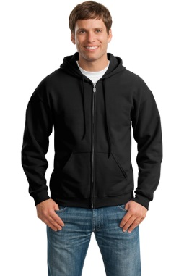
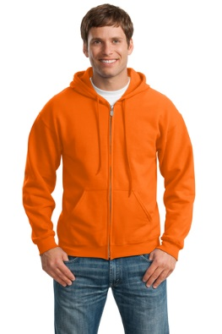

- 8-ounce, 50/50 cotton/poly
- Double-needle stitching at waistband and cuffs
- Unlined hood with dyed-to-match drawcord
- Metal zipper
- 1x1 rib knit cuffs and waistband with spandex
- Front pouch pockets
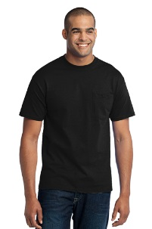
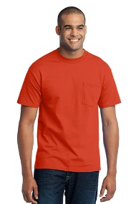

5.5 ounce – 50/50 cotton/polyester
Left chest pocket

All items will be embellished with the 2018 National Open Championship logo on the left chest area of the polos, tees, and hoodies, and on the front middle of hats.

